Lateral Control of Autonomous Vehicle

*Abstract*—Autonomous vehicles and driver-assistance features have become increasingly more common for increased road safety over the past 5 years. In this paper, lateral control of vehicle has been modelled as a MIMO problem and PID, and controllers have been designed and tradeoffs between the controlled designs have been discussed.

Keywords— MIMO, PID,,

# Introduction

In the recent times the automobile design in the industry is towards the direction of using more electronics, controllers for the purpose of improving the functionality and robustness of the system. The area in the vehicle design it is particularly affecting the most is active safety, which in vehicle design quite effectively complements the passive safety. Structural integrity of vehicle components is the purpose of passive safety. While on the other hand purpose of active safety is primarily to facilitate improved vehicle control to the driver and stability of the vehicle especially in emergency situations to prevent accidents for example which might be encountered while driving on the slippery parts of the road. In a study conducted from 2005 to 2007, which studied over 5000 crashes, concluded that 11% of the accidents happened because vehicles failed to stay in the proper lane and 22% of the crashes were a result of errors made in lane changing. Robust lateral control as an active safety for lane keeping and lane changing as level 1 autonomy in vehicles has a huge potential to reduce the road crashes for increase the road safety.

# Vehicle lateral dynamics model

In the analysis, kinematic model is used for lateral control of vehicle dynamics. For simplifying the analysis, the vehicle motion is assumed to be planar. For the purpose of neglecting the load transfer during the vehicle motion, the direction of center of gravity is taken as along the one projected into the paper. By the planar assumptions, we require one rotation and one translation for state estimation of the vehicle. The co-ordinate system used for the analysis is shown in figure 1. The x-axis of the vehicle points in the front of the vehicle, the y-axis towards the right hand side from the perspective of the driver and z-axis by right hand rule points towards the ground.

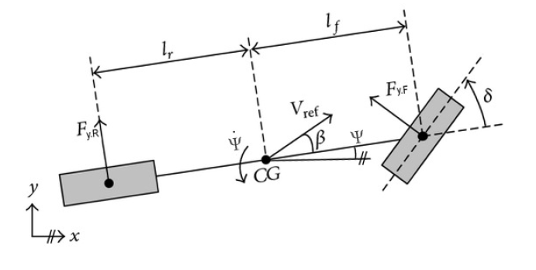

Longitudinal velocity of the vehicle is assumed to be constant for the analysis. The angle between the velocity vector and the front of the vehicle i.e. the x-axis is defined as the vehicle sideslip angle,

where is the velocity in x-direction and is the velocity in y-direction. The tire forces in longitudinal and lateral direction were computed independently for simpler implementation and representation of Pacejka’s ’Magic’ formula. The simplified form is,

where B,C,D and E are the parameters which give the shape of the characteristics of the tire, is lateral tire force and is sideslip angle of the tire. In the analysis, linear model of the tire is used,

where is tire force in the x-direction and is tire force in the x-direction, is tire slip, is tire slip coefficient

and is tire sideslip coefficient. When the sideslip angle is close to zero, the model gives accurate results. Non-linear behavior of the tire is not included in the model.

By balancing the forces in x and y direction and moments in the z direction at equilibrium we get the following equation,

In these equations, m is the mass of the vehicle, is the yaw rate of the vehicle, and are the distances between the center of gravity of the vehicle and the front and rear tire respectively, is moment of inertia of the vehicle about the z-axis, is the sideslip angle, is the steering angle of the front wheel, and are the forces in the x-direction i.e. longitudinal direction of front and rear tire respectively, similarly and are the forces in the y-direction i.e. lateral direction of front and rear tire respectively.

The tire forces are defined using the tire model. Sideslip angles of tires are significantly impacted by tire position and steering angle,

Where and are the front and rear tire sideslip angles respectively. The equation for the tire slip angles can be written as,

With the assumption of small steering angle and sideslip angles the force and moment equilibrium vehicle differential equations can be written as,

These equations can be put in state space form with lateral velocity and vehicle yaw rate as state variables,

= +

Where the brake steer force and brake steer moment is,

,

T is the vehicle track. The state space model has two inputs and two outputs.

|  |  |
| --- | --- |
| Weight | 1000kg |
| Vehicle speed | 20 m/s |
| Moment of inertia | 1500 kg |
| Vehicle track | 1.5m |
| Distance of front wheel and CG | 1m |
| Distance of rear wheel and CG | 1.5m |
| Nominal cornering stiffness of front tire | 55000 N/rad |
| Nominal cornering stiffness of rear tire | 45000 N/rad |

For the controller design in the state space form, the C matrix is taken as identity and D matrix are the disturbances.

# PID Controller design

The controller design using PID is a relatively extreme form of a phase lead-lag compensator design having one of the poles at origin and the other pole tending to infinity. The PI and the PD controller designs similar to PID are extreme cases of phase-lag and phase-lead compensators, respectively. A PID control has the following standard form of transfer function,

Where, and are proportional, integral and derivative gains respectively.

The procedure used to design the PID control was, first the proportional gain was increased to an extent when he oscillations in the system increased to a considerable extent, then the derivative gain was increased to damp those oscillations and then the integral gain was increased to remove the steady state errors. The results obtained are as follows,

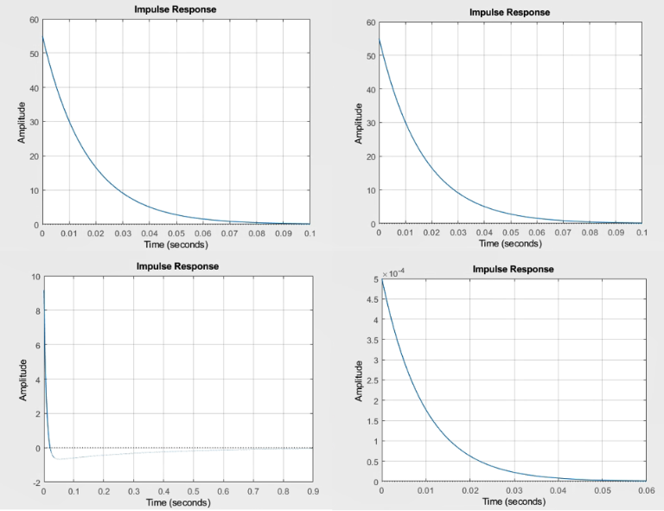

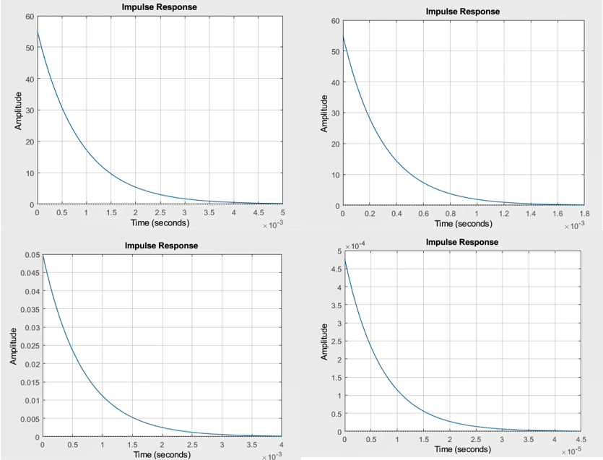

As we can note, PID controller works very well. The system settles down with the controller more than 20 times faster as compared to the uncontrolled system.

# controller design

Keep your text and graphic files separate until after the text has been formatted and styled. Do not use hard tabs, and limit use of hard returns to only one return at the end of a paragraph. Do not add any kind of pagination anywhere in the paper. Do not number text heads-the template will do that for you.

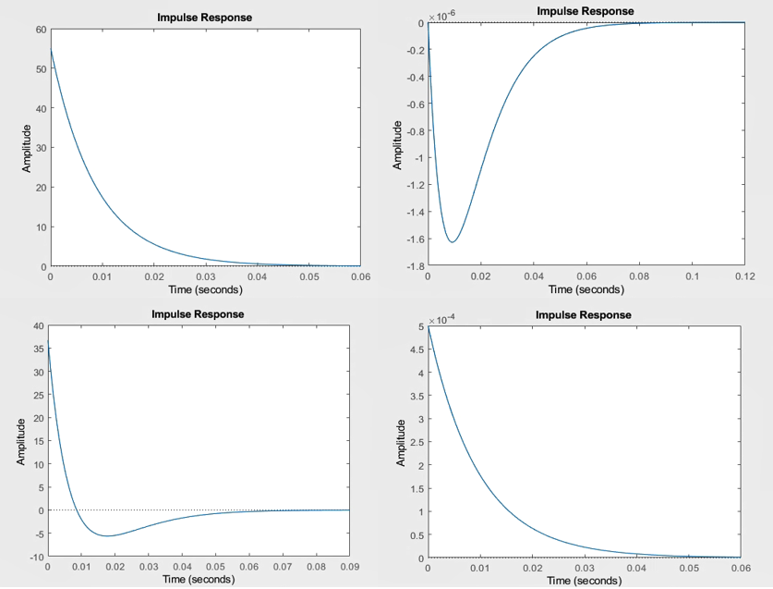

# Controller design

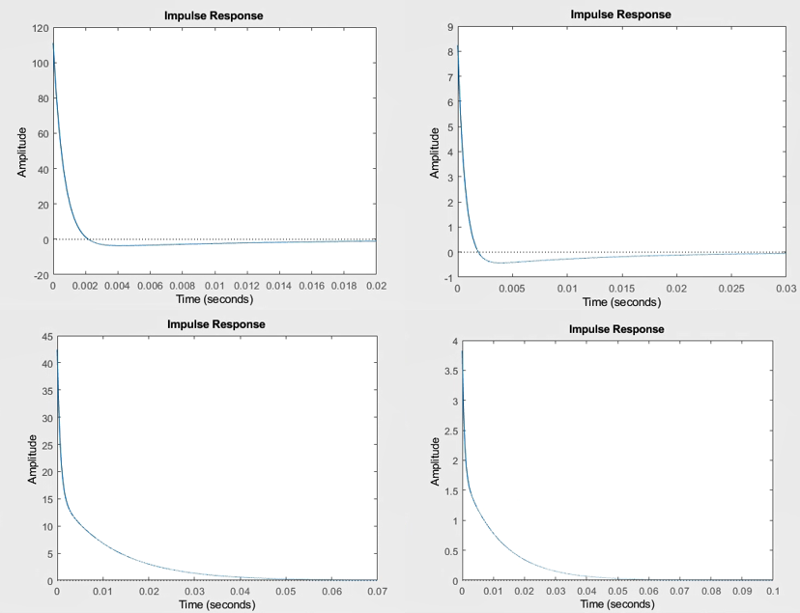

After the text edit has been completed, the paper is ready for the template. Duplicate the template file by using the Save As command, and use the naming convention prescribed by your conference for the name of your paper. In this newly created file, highlight all of the contents and import your prepared text file. You are now ready to style your paper; use the scroll down window on the left of the MS Word Formatting toolbar.

# Attenuation to disturbances

## 

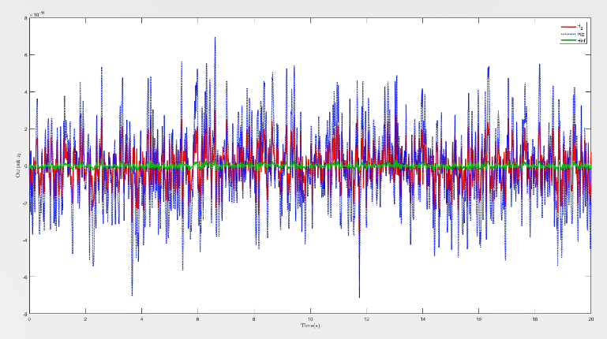

## Authors and Affiliations

**The template is designed for, but not limited to, six authors.** A minimum of one author is required for all conference articles. Author names should be listed starting from left to right and then moving down to the next line. This is the author sequence that will be used in future citations and by indexing services. Names should not be listed in columns nor group by affiliation. Please keep your affiliations as succinct as possible (for example, do not differentiate among departments of the same organization).

### For papers with more than six authors: Add author names horizontally, moving to a third row if needed for more than 8 authors.

### For papers with less than six authors: To change the default, adjust the template as follows.

#### Selection: Highlight all author and affiliation lines.

#### Change number of columns: Select the Columns icon from the MS Word Standard toolbar and then select the correct number of columns from the selection palette.

#### Deletion: Delete the author and affiliation lines for the extra authors.

## Identify the Headings

Headings, or heads, are organizational devices that guide the reader through your paper. There are two types: component heads and text heads.

Component heads identify the different components of your paper and are not topically subordinate to each other. Examples include Acknowledgments and References and, for these, the correct style to use is “Heading 5”. Use “figure caption” for your Figure captions, and “table head” for your table title. Run-in heads, such as “Abstract”, will require you to apply a style (in this case, italic) in addition to the style provided by the drop down menu to differentiate the head from the text.

Text heads organize the topics on a relational, hierarchical basis. For example, the paper title is the primary text head because all subsequent material relates and elaborates on this one topic. If there are two or more sub-topics, the next level head (uppercase Roman numerals) should be used and, conversely, if there are not at least two sub-topics, then no subheads should be introduced. Styles named “Heading 1”, “Heading 2”, “Heading 3”, and “Heading 4” are prescribed.

## Figures and Tables

#### Positioning Figures and Tables: Place figures and tables at the top and bottom of columns. Avoid placing them in the middle of columns. Large figures and tables may span across both columns. Figure captions should be below the figures; table heads should appear above the tables. Insert figures and tables after they are cited in the text. Use the abbreviation “Fig. 1”, even at the beginning of a sentence.

1. Table Type Styles

| Table Head | Table Column Head | | |
| --- | --- | --- | --- |
| Table column subhead | Subhead | Subhead |
| copy | More table copya |  |  |

1. Sample of a Table footnote. (*Table footnote*)
2. Example of a figure caption. (*figure caption*)

Figure Labels: Use 8 point Times New Roman for Figure labels. Use words rather than symbols or abbreviations when writing Figure axis labels to avoid confusing the reader. As an example, write the quantity “Magnetization”, or “Magnetization, M”, not just “M”. If including units in the label, present them within parentheses. Do not label axes only with units. In the example, write “Magnetization (A/m)” or “Magnetization {A[m(1)]}”, not just “A/m”. Do not label axes with a ratio of quantities and units. For example, write “Temperature (K)”, not “Temperature/K”.

##### Acknowledgment *(Heading 5)*

The preferred spelling of the word “acknowledgment” in America is without an “e” after the “g”. Avoid the stilted expression “one of us (R. B. G.) thanks ...”. Instead, try “R. B. G. thanks...”. Put sponsor acknowledgments in the unnumbered footnote on the first page.

##### References

The template will number citations consecutively within brackets [1]. The sentence punctuation follows the bracket [2]. Refer simply to the reference number, as in [3]—do not use “Ref. [3]” or “reference [3]” except at the beginning of a sentence: “Reference [3] was the first ...”

Number footnotes separately in superscripts. Place the actual footnote at the bottom of the column in which it was cited. Do not put footnotes in the abstract or reference list. Use letters for table footnotes.

Unless there are six authors or more give all authors’ names; do not use “et al.”. Papers that have not been published, even if they have been submitted for publication, should be cited as “unpublished” [4]. Papers that have been accepted for publication should be cited as “in press” [5]. Capitalize only the first word in a paper title, except for proper nouns and element symbols.

For papers published in translation journals, please give the English citation first, followed by the original foreign-language citation [6].

1. G. Eason, B. Noble, and I. N. Sneddon, “On certain integrals of Lipschitz-Hankel type involving products of Bessel functions,” Phil. Trans. Roy. Soc. London, vol. A247, pp. 529–551, April 1955. *(references)*
2. J. Clerk Maxwell, A Treatise on Electricity and Magnetism, 3rd ed., vol. 2. Oxford: Clarendon, 1892, pp.68–73.
3. I. S. Jacobs and C. P. Bean, “Fine particles, thin films and exchange anisotropy,” in Magnetism, vol. III, G. T. Rado and H. Suhl, Eds. New York: Academic, 1963, pp. 271–350.
4. K. Elissa, “Title of paper if known,” unpublished.
5. R. Nicole, “Title of paper with only first word capitalized,” J. Name Stand. Abbrev., in press.
6. Y. Yorozu, M. Hirano, K. Oka, and Y. Tagawa, “Electron spectroscopy studies on magneto-optical media and plastic substrate interface,” IEEE Transl. J. Magn. Japan, vol. 2, pp. 740–741, August 1987 [Digests 9th Annual Conf. Magnetics Japan, p. 301, 1982].
7. M. Young, The Technical Writer’s Handbook. Mill Valley, CA: University Science, 1989.

**IEEE conference templates contain guidance text for composing and formatting conference papers. Please ensure that all template text is removed from your conference paper prior to submission to the conference. Failure to remove template text from your paper may result in your paper not being published.**